Spartan Challenge: Week 3
Strength of Leonidas
Time to get your 1 rep maxes for the squat, bench and deadlift
- 1RM Squat (Hip crease MUST be even with or lower than your knees for the rep to count!)
- 1RM Bench Press (Bar MUST touch your chest without bouncing off)
- 1RM Deadlift (Straight bar only/NO hexbar!)
You do NOT have to complete all 3 lifts in one day or even do all of the lifts. Please Note though, we are judging the total weight lifted.
We are using WILKS: a bodyweight to weight lifted ratio to judge fairly
Highest Wilks total wins!
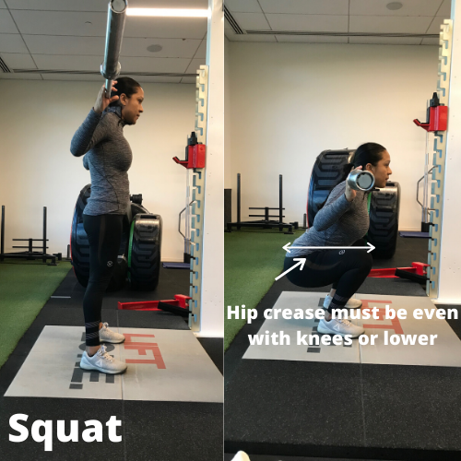 | 