UNITED STATES CORPORATE ATHLETICS ASSOCIATION

Regional Track & Field Championship - 2022

sponsored by the Houston Corporate Athletics Association

April 30, 2022

at Barnett Sports Complex

The Regional Championship is an all-relay meet designed to provide a fun,
team-oriented competition for all corporate competitors, regardless of age or sex.
The event will be sanctioned by USA Track & Field.

ELIGIBILITY
COMPANIES: Participating companies (e.g., corporations, partnerships, proprietorships, non-profit agencies, government agencies, etc.) must be members of the Houston Corporate Athletic Association (HCAA). Team/Company Membership annual membership in included in the meet entry fee. Call 713-828-3525 for registration information.
COMPETITORS: All full-time (minimum of 32 hours a week) employees continuously employed since April 14, 2022 are eligible; however, persons working reduced hours or on leave following the birth of a child will remain eligible to compete. Direct-employed college-level summer interns are eligible, without waiting period limitations, provided that their hiring was based on academic ability and/or related experience and not based on athletic abilities.
Contract employees of a corporation are eligible if they have worked solely and continuously for that corporation (minimum 32 hours a week) since December 1, 2020 or if employed over a longer period with only short breaks in service.
Retirees are eligible if they qualify as annuitants within their corporate policies and do not work full-time for another HCAA-member company.
Alumni: Up to five ex-employees who have previously competed for a team in at least two USCAA Regional or National Track & Field Championships (or as many as the team has competed in, whichever is less), are eligible to compete for that team, provided they are not employed by another competing HCAA team. They may not run in the Executive Relay.
Specifically excluded are temporary employees, board members who are not full time employees of the company, consultants, and persons on formal leave-of-absence.
Direct all questions to the Registration Chairman at 713-828-3525.

LOCATION OF EVENTS
All events will be held at HISD’s Barnett Sports Complex, which is physically located in the vicinity of the intersection of I-610 and I-45 (Gulf Freeway) (see page 6). Consult Google maps or a similar internet site to determine the best approach from your location. We suggest you park on the west side of the track stadium.

VOLUNTEERS REQUIRED
Each team will be expected to provide volunteers to help run the meet. Teams with ten or more participants should have two volunteers available, whereas smaller teams should try to provide at least one volunteer. Volunteers can spell one another, but each team's volunteers should cover their slots with a minimum of discontinuity. Six volunteer categories are available, including: scoring and registration, track (timers, lane judges, etc.), high jump, long jump, shot put, javelin, and discus. Many positions require no experience.

CHECK-IN
Check-in for the field events will occur at the event site (i.e., discus ring, jump pit, etc.). Note that the weight events will be in a separate field located south of the main track.

Check-in for the running events will be held at the clerk's table on the infield of the track. Relay teams must file their RELAY CHECK-IN FORM with the clerk no later than 30 minutes prior to the scheduled start of the event. Please write legibly.

TEAMS SCRATCHING FROM EVENTS SHOULD NOTIFY THE CLERK! This will help the meet run on time.

MAXIMUM NUMBER OF EVENTS RULE
No individual may compete in more than three running events or more than four events total.

RULES ON THE TRACK
The general rules of track and field will apply. Relay teams may be disqualified for:
- FOULS, particularly those resulting in trips or falls (safety is an uppermost consideration in this event). Fouls would include cutting in on other runners before establishing a clear lead, pushing other runners, causing collisions in the relay exchange zones by coming out of the appropriate lane, etc.
- LANE VIOLATIONS resulting in a shortening of the course
- EXCHANGE ZONE VIOLATIONS - all exchanges must be made within the indicated zones
- FALSE STARTS - A warning will be issued after a single false start. Once a team has been warned, any false start by that team may result in disqualification.

AWARDS
Medals will be awarded to the top two teams.

All awards will be distributed at the track directly following the conclusion of the meet. Please stay and join in the fun.

TEAM SCORING
Points will be accumulated for each company team based on its relay team place finishes throughout the competition. Points awarded for each event will be as follows:

1st, 15 points; 2nd, 12; 3rd, 10; 4th, 8; 5th, 7; 6th, 6; 7th, 5; 8th, 4; 9th, 3; 10th, 2; 11+, 1

In computing the final score, the three lowest event scores for each team will be dropped. In the event that teams are ties based on total points, places will be determined according to the number of first place finishes, or if the tie persists, according to the greater number of second-place finishes, and so on. If the scores are still tied, the fastest time in the 3000-meter race will be used to determine place.

POST-MEET PARTY
No party is planned at this time.
Schedule of Events

Weight Events (in field to south of track stadium)
8:30 AM | Javelin (Men and Women)
9:30 AM | Shot Put (Men and Women)
 | Following javelin
10:30 AM | Discus (Men and Women)
 | Following shot put
Running and Jumping Events
8:15 AM | 3200-meter - MEN under 40
8:35 AM | 3200-meter - MEN 40 and over
9:00 AM | 3200-meter - WOMEN (like run all together)
9:25 AM | 3200-meter - WOMEN (2nd heat if needed)
9:15 AM | High Jump (Men)
 | Long Jump (Women)
10:00 AM | Men's Mile - Division I & II
10:15 AM | Submaster's Distance Medley - Division I & II
10:35 AM | Women's 800-meters - Division I
10:45 AM | Three-Lap Sprint - Division I & II (2 heats if needed)
11:00 AM | High Jump (Women)
 | Long Jump (Men)
11:00 AM | Executive Relay - Division I
11:15 AM | Distance Medley Relay - Division I
11:45 AM | Women's Relay - Division I & II
11:55 AM | Submaster's Sprint Medley - Division I & II (2 heats if needed)
12:10 PM | KIDS RACE (kids of all ages welcome)
12:25 PM | Senior’s Relay
12:35 PM | 4 x 100M Relay - Division I & II
12:45 PM | Pyramid Relay - Division I & II
1:00 PM | Master's Relay - Division I & II
1:15 PM | Sprint Relay - Division I & II (2 heats if needed)
Awards (~15 minutes after last relay)

3:15 PM | Need to be out of stadium (weather permitting)

DRINK PLENTY OF FLUIDS !
Description of Events - Track Relays

3200-METER TEAM RACES ( changed from 3000m to reduce confusion/improve logistics)
Men's and women's teams will be scored separately. An unlimited number of runners may be entered. Teams will be formed using the best five men and best four women (three men and two women for Division II) based on place finish within age category (M = 18-29, 30-39, 40-49, 50-59, 60+; W = 18-29, 30-39, 40-49, 50+). Team scores will be determined using the standard HCAA cross-country scoring system. Ties will be broken using the "best place finish" rule. "B" and "C" teams will be formed if enough runners finish.
MEN'S MILE
A team race with two men running the mile simultaneously. Team score is determined by adding the place finishes of the two runners. Team places are awarded on the basis of team scores (lowest score wins). Ties will be broken using the "fastest finisher" rule.
SUBMASTER'S DISTANCE MEDLEY (800-400-1200-1600)
A four-person baton relay in which all competitors must be 30 years of age or older. The team must include at least one female. Two of the males must be 35 or older.
WOMEN'S 800-METERS
A team race with two women running 800 meters simultaneously. Team score is determined by
adding the place finishes of the two runners. Team places are awarded on the basis of team
scores (lowest score wins). Ties will be broken using the "fastest finisher" rule.
3-LAP SPRINT (200-200-400-400)
A four-person baton relay with at least one woman runner.
EXECUTIVE RELAY (800-400-800-1600)
A four-person baton relay in which all runners must be at least 25 years of age and three of the
four must be at least 30. All four runners must be at the level of manager or above (a supervisor of
supervisors).
DISTANCE MEDLEY RELAY (1600-1600-800-800-1600)
A five-person baton relay in which the first 1600-meter leg is run by a female and the second
1600 leg is run by a male aged 40 or older.
WOMEN'S RELAY (800-400-400)
A three-woman baton relay with at least one woman age 30 or over.
SUBMASTER'S SPRINT MEDLEY (200-200-400-800)
A four-person baton relay in which all competitors must be 30 years of age or older. The team must include at least one female. Two of the males must be 35 or older.
SENIOR’S RELAY (400-200-600-400)
A four-person baton relay in which all competitors must be 50 years of age or older. The team must include at least one female.
4 x 100M RELAY (100-100-100-100)
A four-person baton relay with runners in the following order: 35+ Woman, Open Woman, 40+ Man, Open Man.
PYRAMID RELAY (400-800-1200-800-400)
A five-person baton relay with at least two women runners.
MASTER'S RELAY (800-400-800)
A three-person baton relay in which all runners must be age 40 or older. At least one runner
must be a woman.
SPRINT RELAY (200-200-400-400-200-200)
A six-person baton relay with at least two women and one male age 40 or over.

Description of Events - Field Relays

JUMP RELAY
An unlimited number of participants may be entered. Each person competes in both the long jump and high jump. Individual scores are the sum of the high and long jump ratings, which are calculated as a percentage of the standards for the applicable age-sex group (as listed in table below). The team scores ("A" team) are the sum of the two highest individual scores. "B" and "C" teams will be formed if enough jumpers compete.
WEIGHT RELAY
An unlimited number of participants may be entered. Each person must compete in at least two of the three weight events: shot put, discus, and javelin. Individual scores are the sum of the best two effort ratings, which are calculated as a percentage of the standards for the applicable age-sex group (as listed in table below). The team scores ("A" team) are the sum of the two highest individual scores. "B" and "C" teams will be formed if enough throwers compete.

Performance Standards for Field Events*
 | High Jump |  | Long Jump |  | Shot Put |  | Discus |  | Javelin
AGE | Men | Women | Men | Women | Men | Women | Men | Women | Men | Women
16-29 | 7-11 | 6-10 | 28-10 | 24-5 | 66-11 | 64-3 | 228-0 | 216-6 | 296-8 | 216-11
30-34 | 7-9 | 6-8 | 28-3 | 23-11 | 66-2 | 61-9 | 227-9 | 216-4 | 297-10 | 199-0
35-39 | 7-5 | 6-4 | 26-11 | 22-8 | 62-10 | 59-6 | 216-4 | 203-4 | 262-6 | 180-9
40-44 | 7-1 | 6-0 | 25-6 | 21-4 | 59-6 | 55-2 | 205-5 | 191-3 | 247-3 | 164-4
45-49 | 6-9 | 5-8 | 24-0 | 20-0 | 56-3 | 50-7 | 193-3 | 179-0 | 233-7 | 148-1
50-54 | 6-5 | 5-3 | 22-6 | 18-8 | 58-6 | 52-3 | 202-8 | 165-3 | 216-6 | 144-7
55-59 | 6-1 | 4-11 | 21-1 | 17-5 | 54-10 | 47-3 | 190-0 | 151-5 | 192-7 | 129-11
60+ | 5-9 | 4-8 | 19-8 | 16-2 | 54-2 | 42-7 | 203-7 | 137-11 | 195-2 | 116-0
* all distances are in feet-inches

Weights of Implements
 | Shot Put |  | Discus |  | Javelin
AGE | Men | Women | Men | Women | Men | Women
16-49 | 16 lb | 4 kg | 2.0 kg | 1.0 kg | 800 g | 600 g
50-59 | 6 kg | 4 kg | 1.5 kg | 1.0 kg | 800 g | 600 g
60+ | 5 kg | 3 kg | 1.0 kg | 1.0 kg | 600 g | 400 g

Description of Events - Just for Fun

KID's RACE
This is a non-scoring event designed to help children at the meet burn off some energy. Children of athletes, from toddlers up to roughly 14 years of age, are welcome to compete. Races are by age group and race lengths are age-appropriate ranging from about 20 m for the littlest to 100-200 m for the older kids.
Location of Meet

Barnett Sports Complex is physically located at 6800 Fairway Drive, Houston, TX 77087 in the vicinity of the intersection of I-45 (Gulf Freeway) and the southeast portion of Loop 610. As there are four principal means of approach to this intersection, it is best to consult Google maps or another map/routing source to identify your preferred route. There is ample parking space available at the track, with access to the parking from Fairway Dr. It is expected that only the gate at the southwest corner of the stadium facility will be open, so park in that area (as indicated on following page).

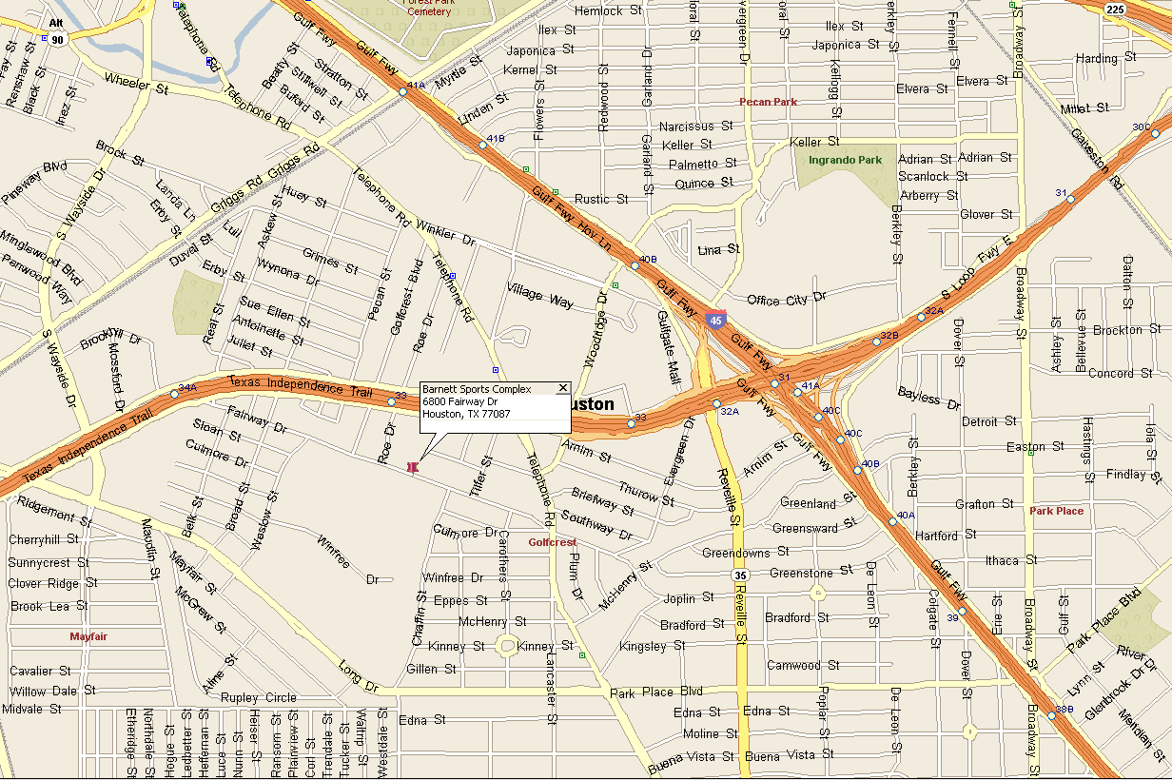
To Downtown
To Galveston

BEAT THE HEAT – DRINK LOTS OF FLUIDS

Know about Heat Exhaustion and Heat Stroke: Heat exhaustion occurs when someone overheats. Heat stroke is a more severe illness that occurs under the same circumstances, but can be life-threatening. Either can occur under the following conditions:
- Heavy and/or prolonged activity in hot environment
- Too little fluid and salt intake
- Risk can be increased by certain drugs, including Antihistamines, Amphetamines, Alcohol
Symptoms
- heat exhaustion may include: Temperature over 100°F, Fast pulse, MOIST SKIN, SWEATING, Muscle cramps, Nausea, Vomiting, Dizziness or Lightheadedness, Confusion
- heat stroke may include: High temperature (about 105° F), Weakness, Dizziness, Blurred vision, Confusion, delirium, unconsciousness, NO SWEATING, Pale, dry skin, Fast breathing, fast irregular pulse
- The victim often will not recognize the symptoms in themselves. Watch your friends.

Prevention: If you are going to exercise under hot conditions, drink lots of fluids and take frequent breaks in the shade. Helpful fluids include water and sports drinks which contain both salt and sugar.
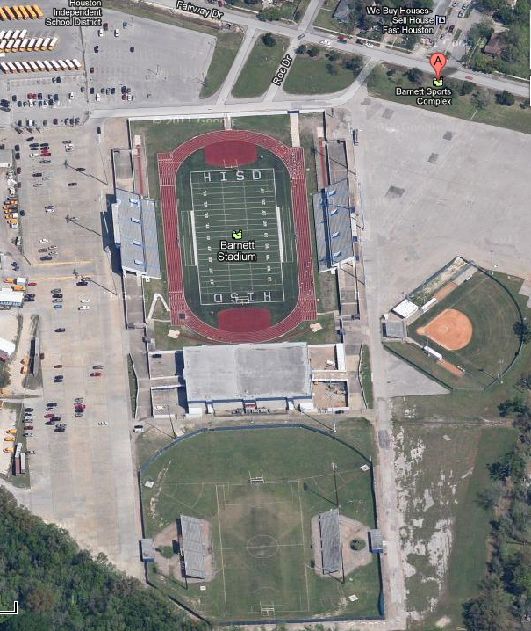
ENTRANCE
Parking
long jump
discus
javelin
shotput

WHAT TO BRING
- Hat
- Sunscreen
- Fluids (water fountains in stadium concourse areas) and cups/ice
- Snacks (NOTE: We are expecting a concession stand to be open with food, sports drinks, etc.)
- Shade (e.g., tent or canopy for team – coordinate this with team captain; there are grassy areas around the perimeter of the field). There is also shade available in the stands or in the concourses under the stands
- Trash bags (we need to clean up our own trash)
- Rain protection

Emergency Medical Technician services for the meet provided by

Parachute Consulting

HCAA is indebted to Parachute Consulting who will be providing an onsite medic for our meet at costs well below what we would normally incur.

Parachute Consulting is a multi-disciplined firm comprised of dedicated safety and medical professionals with many years of practical experience. Their diverse team including physicians, registered nurses, paramedical specialists, OSHA experts and seasoned educators can provide clients with:
- Onsite medics, medical direction and protocols for land-based work.
- Emergency medical training,
- OSHA and DOT compliance assistance, and emergency preparedness drills,
- Health and safety training,
- Consulting in all areas of health, safety and emergency response.

Website: www.Parachuteconsulting.net
Phone: 713.397.7007
Email: info@parachuteconsulting.net

IN THE EVENT OF RAIN:
The meet is held at a facility featuring an all-weather track. Barring a spectacular rain event like Tropical Storm Allison more than a decade ago, the meet will go on. However, there is potential for schedule delays. In the event of rain:
- Light rain/drizzle – we continue with the competition
- Heavy rain/lightning – delay until clear or drizzle. (The trainer will have a lightning detector. We will pull people under cover in the event of lightning and will resume once 30 minutes has past. )

Note:
- The stadium has lots of covered space on the concourse level and people can also take cover in their vehicles.
- Field events will need to assess the situation at their particular competition location to determine if it is safe to compete. Be prepared for muddy conditions in the field event areas.
- Participants are advised to bring rain gear.

Individual Entry Form and Waiver
For and in consideration of USA Track & Field, Inc. (“USA Track & Field”) allowing me, the undersigned, to participate in the USA Track & Field sanctioned event USCAA Regional Corporate Track & Field Championship (the “Event”); I, for myself, and on behalf of my spouse, children, guardians, heirs and next of kin, and any legal and personal representatives, executors, administrators, successors and assigns, hereby agree to and make the following contractual representations pursuant to this Waiver and Release of Liability, Assumption of Risk and Indemnity Agreement (the “Agreement”);
1. I hereby represent that (i) I am at least eighteen (18) years of age or older; (ii) I am in good health and in proper physical condition to participate in the Event; and (iii) I am not under the influence of alcohol or any illicit or prescription drugs which would in any way impair my ability to safely participate in the Event. I agree that it is my sole responsibility to determine whether I am sufficiently fit and healthy enough to participate in the Event, that I am responsible for my own safety and well being at all times and under all circumstances while at the Event site.
2. I understand and acknowledge that participation in track & field Events is inherently dangerous and represents an extreme test of a person’s physical and mental limits. I understand and acknowledge the risks and dangers associated with participation in the Event and sport of track & field, including without limitation, the potential for serious bodily injury, sickness and disease, permanent disability, paralysis and loss of life; loss of or damage to equipment/property; exposure to extreme conditions and circumstances; contact with other participants, spectators, animals or other natural or manmade objects; dangers arising from adverse weather conditions; imperfect course or track conditions; land, water and surface hazards; equipment failure; inadequate safety measures; participants of varying skill levels; situations beyond the immediate control of the Event Organizers; and other undefined, not readily foreseeable and presently unknown risks and dangers (“Risks”). I understand that these Risks may be caused in whole or in part by my own actions or inactions, the actions or inactions of others participating in the Event, or the negligent acts or omissions of the Released Parties defined below, and I hereby expressly assume all such Risks and responsibility for any damages, liabilities, losses or expenses which I incur as a result of my participation in any Event.
3. I agree to be familiar with and to abide by the Rules and Regulations established for the Event, including but not limited to the Competitive Rules adopted by USA Track & Field and any safety regulations established for the benefit of all participants. I accept sole responsibility for my own conduct and actions while participating in the Event, and the condition and adequacy of my equipment.
4. I hereby Release, Waive and Covenant Not to Sue, and further agree to Indemnify, Defend and Hold Harmless the following parties: USA Track & Field, Inc., its members, member clubs, associations, sport disciplines and divisions; United States Olympic Committee (USOC); the Event Directors, Organizers and Promoters, Sponsors, Advertisers, Coaches and Officials; the Host Organization and the Facility, Venue and Property Owners or Operators upon which the Event takes place; Law Enforcement Agencies and other Public Entities providing support for the Event; and each of their respective parent, subsidiary and affiliated companies, officers, directors, partners, shareholders, members, agents, employees and volunteers (Individually and Collectively, the “Released Parties” or “Event Organizers”), with respect to any liability, claim(s), demand(s), cause(s) of action, damage(s), loss or expense (including court costs and reasonable attorneys fees) of any kind or nature (“Liability”) which may arise out of, result from, or relate in any way to my participation in the Event, including claims for Liability caused in whole or in part by the negligent acts or omissions of the Released Parties. I further agree that if, despite this Agreement, I, or anyone on my behalf, makes a claim for Liability against any of the Released Parties, I will indemnify, defend and hold harmless each of the Released Parties from any such Liabilities which any may be incurred as the result of such claim.
I hereby warrant that I am of legal age and competent to enter into this Agreement, that I have read this Agreement carefully, understand its terms and conditions, acknowledge that I will be giving up substantial legal rights by signing it (including the rights of my spouse, children, guardians, heirs and next of kin, and any legal and personal representatives, executors, administrators, successors and assigns), acknowledge that I have signed this Agreement without any inducement, assurance or guarantee, and intend for my signature to serve as confirmation of my complete and unconditional acceptance of the terms, conditions and provisions of this Agreement. This Agreement represents the complete understanding between the parties regarding these issues and no oral representations, statements or inducements have been made apart from this Agreement. If any provision of this Agreement is held to be unlawful, void, or for any reason unenforceable, then that provision shall be deemed severable from this Agreement and shall not affect the validity and enforceability of any remaining provisions.

 | Signature |  | Date

Address ___________________________________________________________________________

Phone _________________ Age ________ Sex _______

Personal Information
Name |  |  |  |  |  | Age on 12/31/2021_______
Address |  |  |  |  |  | Sex (circle): Male Female
City, State, Zip |  |  |  |  | Phone (wk)
Company |  |  |  |  | Phone (hm)
Emergency Contact |  |  |  |  | Phone

Preferred Events: |  | (for your team captain's information)
 | ______ 100 m | ______ 800 m | _______ High/Long Jump
 | ______ 200 m | ______ 1600/Mile | _______ Shot/Discus/Javelin
 | ______ 400 m | ______ 3000 m

Return this form and waiver on previous page to your team captain at:

BY NO LATER THAN: ________________________, 2022

Team Captain: Completed “Individual Entry Form and Waiver” forms for all participants must be provided to the Meet Director at the Meet prior to the event start (8:15am).

ALL PARTICIPANTS MUST SIGN WAIVER ON OPPOSITE SIDE OF PAGE

