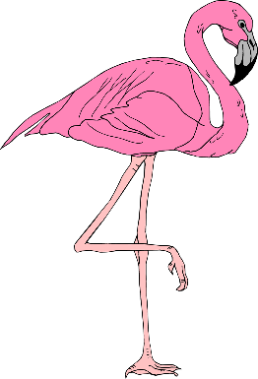
Balance
Challenge

Challenge will be for 2 weeks from Sept. 11th to 22nd Let’s Practice First!

 | TIME (BOTH SIDES)
 | Level 1 | Level 2 | Level 3
DAY 1
DAY 2
DAY 3
DAY 4
DAY 5
DAY 6
DAY 7
Work up to balancing on each leg at starting from 20 sec to a full 60 sec over the course of seven days. Keep track of your progress with this handy chart. After some practice, lets test it in the gym all 3 challenges listed above and see how long you can hold.
Longest hold gets a prize.

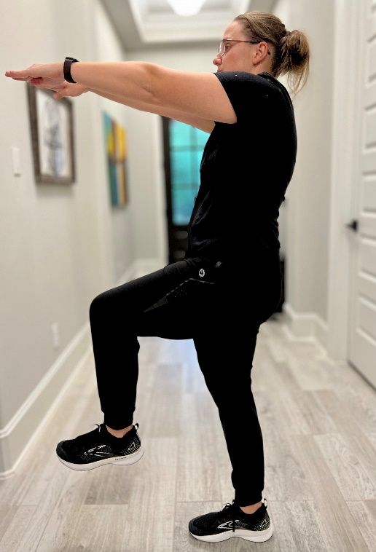
Level 1:
How long can you balance on one leg at 90°?

Stand upright with feet hip distance apart. Stabilize the core and focus your eyes on a focal point on the wall or floor in front of you. Lift one of the legs at 90 degrees in front of you and keep the foot flexed. Extend the arms and place them at shoulder height. If you need balance support, place one hand on a wall or chair while practicing. Repeat on other leg.

Level 3:
How long can you balance on one leg at 90° with eyes closed?

Same stance as level one, but with eyes closed. Remember if you need balance support, place one hand on a wall or chair while practicing. Repeat on other leg.

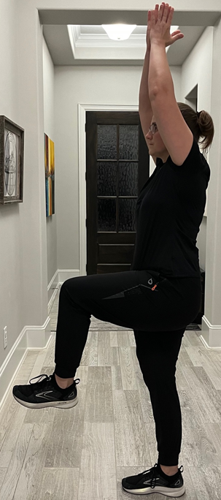
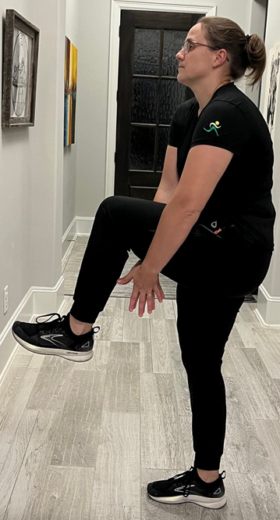
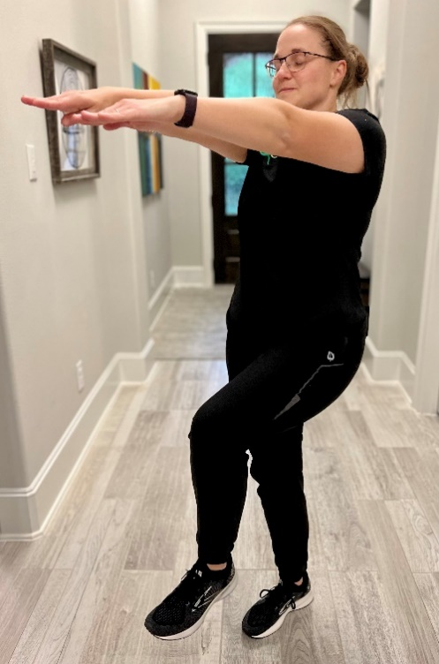
Scan for more details
Level 2:
How long can you balance on one leg at 90° and clap under your leg and then above your head?

Start balancing on one leg, with other leg 90-degree angle in front of you and your hands together overhead. Crunch forward and clap your hands under the raised leg. Continue to clap over your head and under as many times as you can. Repeat on your other leg.

