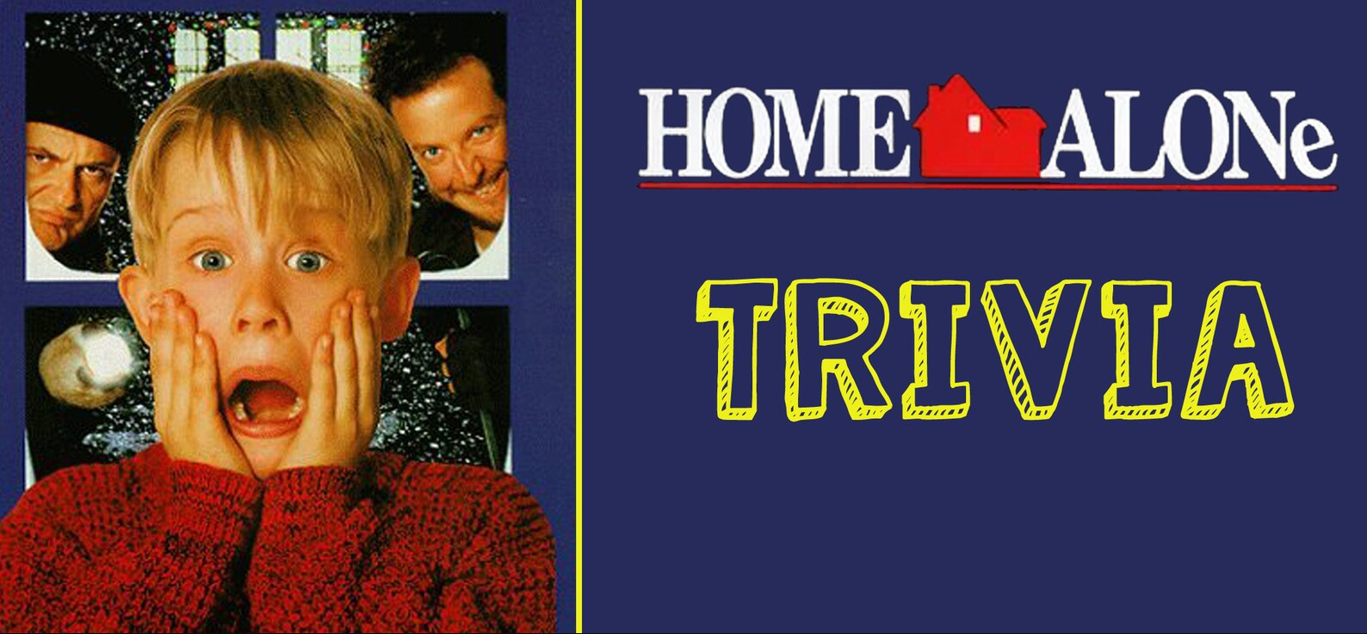

- In which year was the film Home Alone released?_______________
- What is the age of the main character in the film? _______________
- What is Kevin's cousin Fuller known to do while sleeping at night? _______________
- What’s the name of Kevin’s obnoxious brother?_______________
- Where are the McCallister’s going on vacation?_______________
- What street do the McCallister’s live on? _______________
- What nickname did Marv and Harry refer to themselves, when getting placed in the police car? _______________
- What hits the burglars in the face as they run up the stairs to catch Kevin? _______________
- What do the burglars call the McAllister’s home? _______________
- What’s the name of the old man who saves the day? _______________

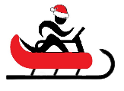
Name When Completed:

