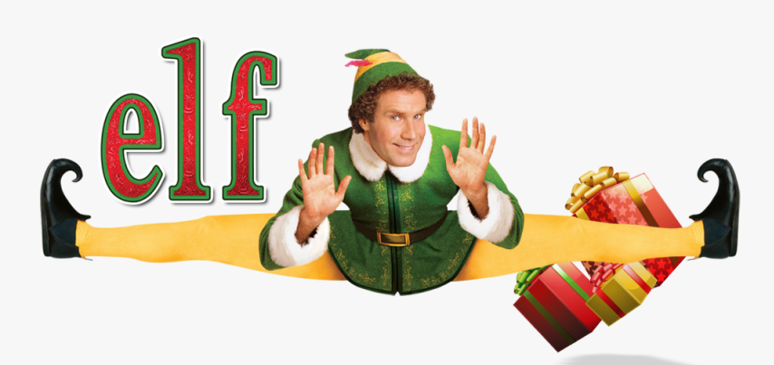

Workout

Warm-Up: North Pole Stretching

1. Snowball Fight (Jogging in Place): 3 min.

2. Elf Splits (Lunges): 10 on each leg

3. Candy Cane Reach (Side Bends): 10 each side

Main Workout: Elf Training Circuit: Repeat 3-5x each exercise.

1. Sleigh Pull (Resistance Band Rows): 15 reps

2. Santa's Lift (Deadlifts): 15 reps

3. Gingerbread Man Race (High Knees): 30 sec.

4. Snow Angel Flutters (Alt. Flutter Kicks): 30 reps

5. Polar Bear Plank: Hold for 30-45 sec.

6. Gift Wrapping Squats: 15 reps

7. Toy Assembly Line (Mountain Climbers): 30 sec.

Cool Down: Christmas Star Cool Down

1. Snowflake Stretch (Child's Pose): Hold for 30 sec.

2. Reindeer Relaxation (Cat-Cow Stretch): 10 reps

3. Santa's Sleigh (Seated Forward Fold): Hold for 30 sec.

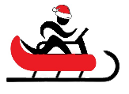
4. Elf Wind Down (Deep Breathing): 1-2 min.
Name When Completed:

