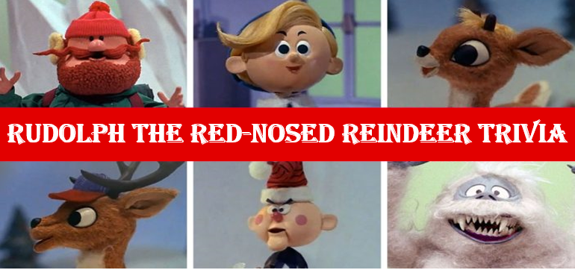

- What was the name of the talking snowman who narrate the story? _______________
- What animal noise did the elf make to distract the Bumble? _______________
- Why is the train on the island of misfit toys? _______________
- What is the name of the doe whom Rudolph likes? _______________
- Which department store was Rudolph created for as part of an advertising campaign? ______________
- How does Donner hide Rudolph’s red nose? ______________
- What song does Clarice sing to Rudolph? ______________
- What was the Bumble’s one weakness? _______________
- What is the name of the prospector? _______________
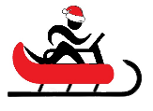
- What obstacle does Rudolph help Santa overcome? _______________
Name When Completed:

