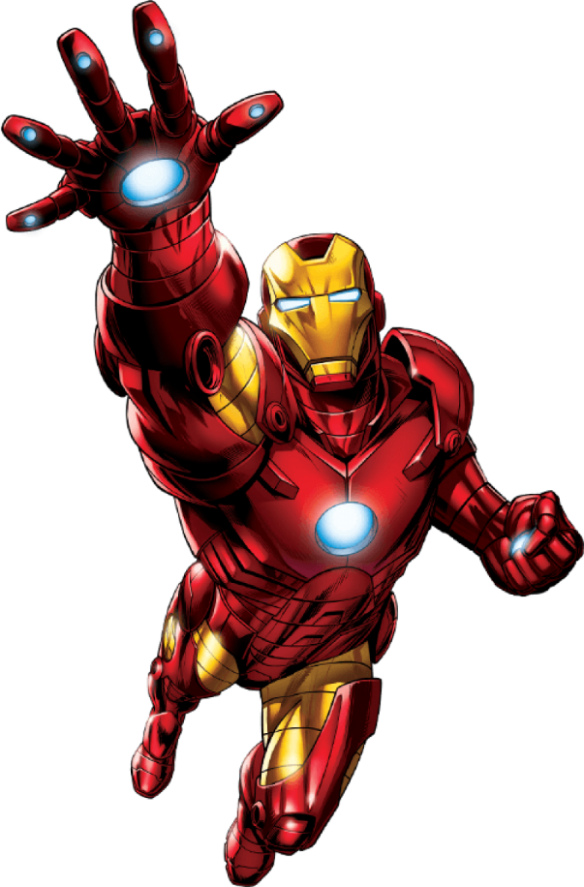
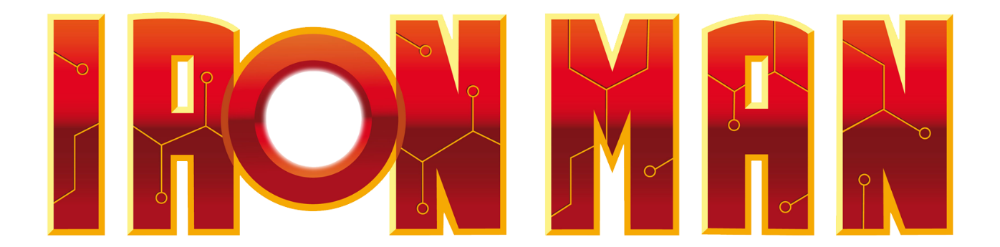

Get ready to train like Tony Stark and become a superhero with the Iron Man Armor Training Workout. This workout focuses on strength, agility, and endurance to help you build the physique of a genius billionaire inventor and superhero.

1. Repulsor Blasts (Barbell Hip Thrusters): 3 sets of 15 reps
- Begin seated on the ground w/bench behind. Barbell should be directly above your hips. Lean back against the bench and raise your hips toward the ceiling.

2. Flight Training (Jumping Lunges): 3 sets of 10 reps on each leg
- Stand with feet hip-width apart. Step forward into a lunge, then jump and switch legs mid-air.

3. Power Arc Reactor (In & Out Kicks): 3 sets of 15 reps
- Sit on bench, arms behind holding the bench. Bring legs into chest and kick out to straight.

4. Pepper Potts (Tricep Kickbacks): 3 sets of 15 reps
- Hold a kettlebell with both hands in front of you. Swing it between your legs, then thrust your hips forward to swing it up to shoulder height.

5. Unibeam Focus (Chest Press w/Legs Extended): 3 sets of 15 reps
- Lay flat on back, legs are extended right above ground. Press weights off chest.

6. Mark XLII Agility (Agility Ladder: In & Out Jumps): 1 minute on ladder
- Set up an agility ladder or create one with tape on the floor. Perform in and out jumps, back and forth for a minute.

Exercises: | Sets  Reps  Wt. | M | T | W | T | F | S | S
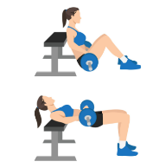  Hip  Thrusters | 3 sets
 | 15 reps
 | Wt.
Jumping  Lunges | 3 sets
 | 10 reps
 | Wt.
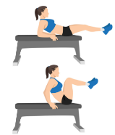  In &  Out Kicks | 3 sets
 | 15 reps
 | Wt.
Tricep  Kickback | 3 sets
 | 15 reps
 | Wt.
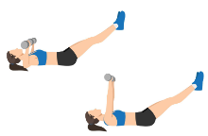  Chest  Press w/  Legs Extended | 3 sets
 | 15 reps
 | Wt.
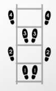  In &  Out  Jumps | 3 sets
 | 1 min.
 | Wt.

Congratulations, superhero! You've completed the Ironman Armor Training Workout and taken a step closer to embodying the resilience and strength of Tony Stark. Keep training like a superhero, and you'll continue to unleash your full potential both in and out of the gym. Suit up and conquer!

Name When Completed:

