Welcome to “The Ultimate Spider-Man Fitness Adventure”, where we swing into action to harness the swift and nimble nature of the web-slinging hero! Get ready to channel your inner Spider-Man with exercises that will test your agility, flexibility, and overall endurance. If you're eager to climb to new heights in your fitness journey.

1. Web Slinger Plie Squats: (3 sets of 15 reps)
- Mimic shooting webs while performing toe pointed out squats with calf raise.

2. Spider Crawl: (3 sets for 20 reps Forward)
- Get into a plank position and crawl like Spiderman, moving your arms and legs simultaneously.

3. Rooftop Leaps: (3 sets of 12 jumps)
- Perform broad jumps forward, landing in a low squat, as if leaping over tall buildings.

4. Peter Parker Oblique Twists: (3 sets of 20 reps)
- Sit with your feet off the ground and twist your torso, touching the ground on each side with your hands.

5. Spidey Sense Side Planks: (3 sets of 30 sec. each side)
- Hold a side plank, focusing on balance and core strength, as if tuning into your Spidey senses.

6. Green Goblin Glute Bridges: (3 sets of 15 reps)
- Lay on your back with knees bent, lifting your hips to strengthen your glutes, ready to face the Green Goblin.

Exercises: | Sets  Reps  Wt. | M | T | W | T | F | S | S
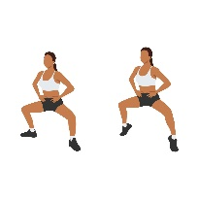  Plie  Squats w/  Calf Raise | 3 sets
 | 15 reps
 | Wt.
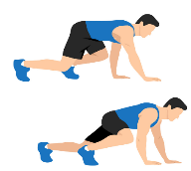  Spider  Crawl | 3 sets
 | 20 reps
 | Wt.
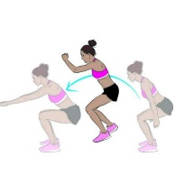  Forward  Broad  Jumps | 3 sets
 | 12 reps
 | Wt.
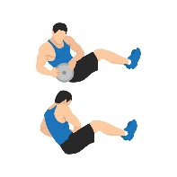  Oblique  Twists | 3 sets
 | 20 reps
 | Wt.
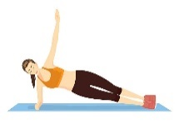  Side  Planks | 3 sets
 | 30 sec.
 | Wt.
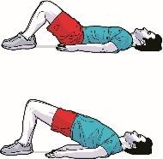  Glute  Bridges | 3 sets
 | 15 reps
 | Wt.

Well done on completing the Ultimate Spiderman Fitness Adventure! Just like Spiderman, you've pushed your limits, demonstrating not only physical strength but also mental resilience. Remember, every day is an opportunity to improve and become your own version of a superhero. Keep challenging yourself and swinging higher!

Name When Completed:

