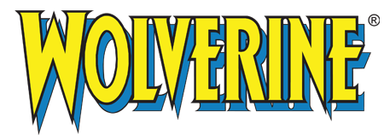

Embark on the Mutant Mettle Challenge, a workout crafted for those aspiring to attain the extraordinary physical prowess of a superhero. Inspired by the legendary toughness and agility of Wolverine, this program is a blend of high-intensity strength training, cardiovascular endurance, and agility exercises. Prepare to push your limits and awaken the relentless warrior within.

1. Heroic Hangs - Dead Hangs: 3 sets of 30 seconds
- Improve your grip strength and endurance, mirroring a hero's need to hang onto ledges or climb structures.

2. Logan's Lunges - Walking Lunges: 3 sets of 12 reps per leg
- Enhance lower body strength and balance, just like Wolverine trekking through the wilderness.

3. Rapid Regeneration - Plank: Hold for 1 minute
-Strengthen your core, symbolizing Wolverine's incredible healing ability.

4. Adamantium Claws - Pull-Ups: 3 sets of 10 reps
-Channel Wolverine’s iconic claws with this upper body strengthener.

5. Agility of the X-Men- Box Jumps: 3 sets of 10 reps
- Boost your explosive power and agility, essential for any superhero.

6. Steel Resolve- Deadlifts: 3 sets of 8 reps
-Build a back and grip strength as strong as adamantium.
Exercises: | Sets  Reps  Wt. | M | T | W | T | F | S | S
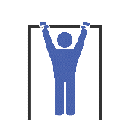  Dead Hangs | 3 sets
 | 30 sec.
 | Wt.
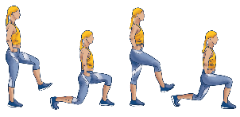  Walking  Lunges | 3 sets
 | 12 reps
 | Wt.
Plank | 3 sets
 | 1 min
 | Wt.
Pull-Ups | 3 sets
 | 10 reps
 | Wt.
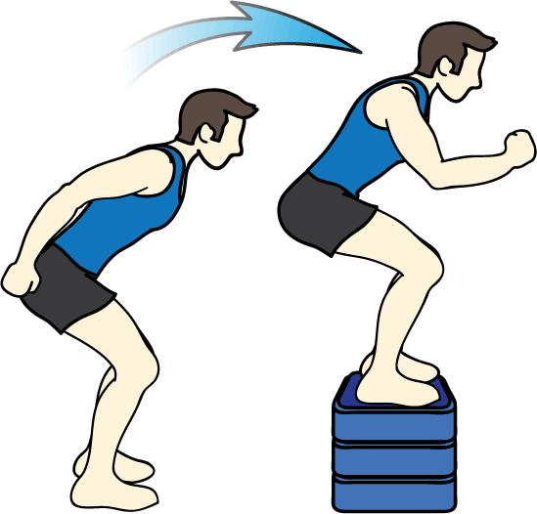  Box Jumps | 3 sets
 | 10 reps
 | Wt.
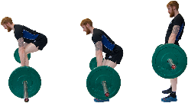  Deadlifts | 3 sets
 | 8 reps
 | Wt.

Well done, champion! You’ve conquered the Mutant Mettle Challenge. You've pushed your body and mind, proving that within you lies a strength and determination akin to Wolverine himself. Remember, like any superhero, consistency is key. Keep challenging yourself with this workout, and you'll continue to see improvements in your strength, endurance, and agility.
Name When Completed:

