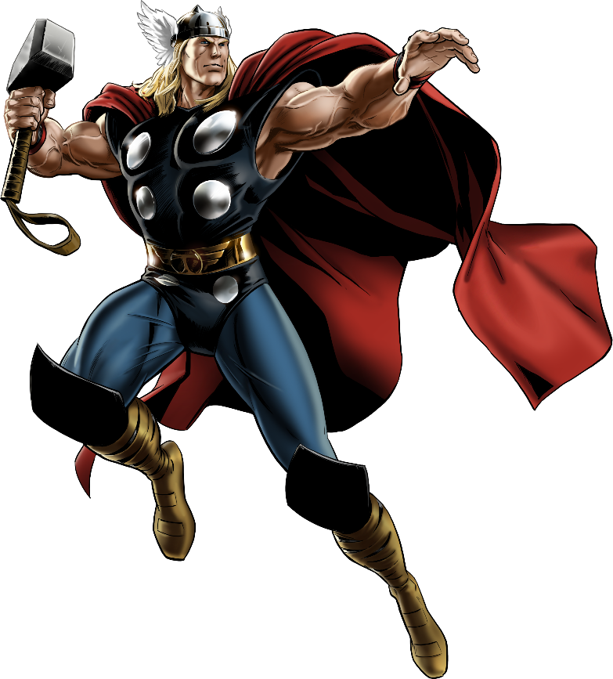

"Thunder God's Power Circuit"
Channel the legendary might of Thor, the Thunder God, in this dynamic workout. Designed to boost your strength and explosive power, this regimen will have you feeling like a true denizen of Asgard. Get ready to unleash the storm within!

1. Hammer Swings (Kettlebell Swings): 3 sets of 15 reps
-Mimic Thor's hammer swing to build core and arm strength.

2. Thunderclaps (Jump Squats): 3 sets of 12 reps
-Explode upwards with force, clapping overhead.

3. Asgardian Curl (Bicep Curl): 3 sets of 15 reps
-Lift heavy, pushing your enemies. 3 sets of 10 reps.

4. Lightning Split Lunges: 3 sets of 15 reps each leg
-Use bench or chair by dipping with power, like striking lightning.

5. Valhalla V-ups: 3 sets of 12 reps
-Engage your core, imagine soaring through the skies of Asgard.

6. Stormbreaker (Speed Skaters): 3 sets of 30sec.
-Full-body explosive movements to summon the storm.

Exercises: | Sets  Reps  Wt. | M | T | W | T | F | S | S
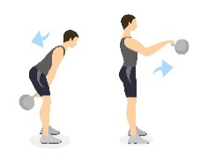  KB  Swings | 3 sets
 | 15 reps
 | Wt.
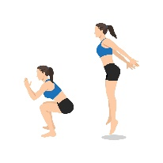  Jump  Squats | 3 sets
 | 12 reps
 | Wt.
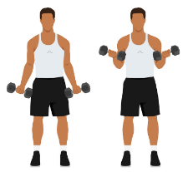  Bicep  Curls | 3 sets
 | 15 reps
 | Wt.
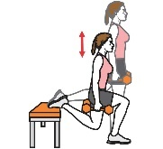  Bench  Split  Lunge | 3 sets
 | 15 reps
 | Wt.
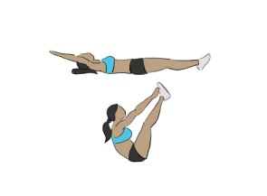  V-ups | 3 sets
 | 12 reps
 | Wt.
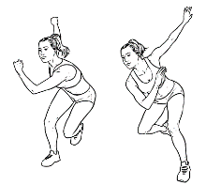  Speed  Skaters | 3 sets
 | 30 sec.
 | Wt.

You've conquered the Thunder God's Power Circuit! Your journey to Asgardian strength is just beginning. Stay dedicated, and soon you'll harness the power of Thor in every workout. Keep pushing the limits, and the skies are the limit!

Name When Completed:

