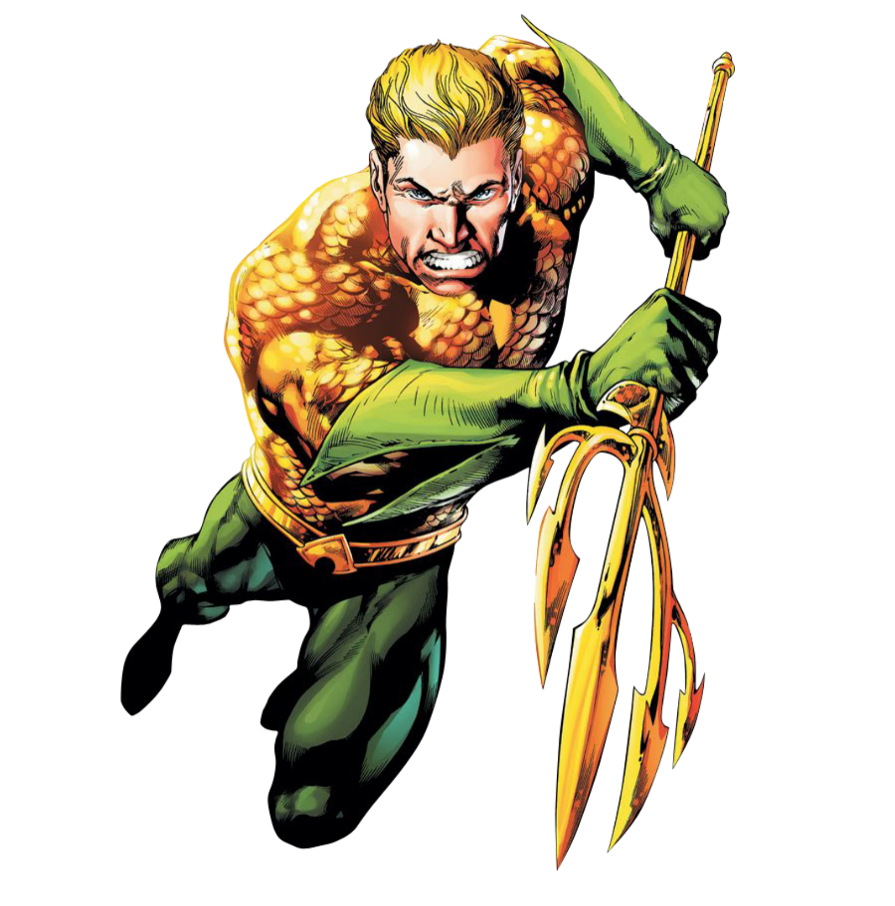

Embark on the “Trident Triumph Circuit” with a blend of strength and agility, drawing from the depths of the ocean for a transformative fitness experience. Immerse yourself in this routine that mirrors the power and resilience of Atlantis.

1. Ocean Wave Swimmers: 3 sets of 30 sec.
- Lie face down, arms extended in front. Lift arms, chest, and legs off the ground simultaneously. Flutter arms and legs like swimming.

2. Wave Rider Leg Raises: 3 sets of 20 reps
- Lie on your back, arms under butt. Lift your legs in a fluid, wave-like motion, engaging your core.

3. Clams w/Band: 3 sets of 15 reps
- Put band right above knee and lay on side. Open legs like a clam. Keeping your feet together like the hinge of the clam.

4. Crab Walk w/Band: 3 sets of 15 steps
- Put band right above knee and squat down, walk side to side like a crab in the ocean.

5. Starfish Crunch: 3 sets of 20 reps
- Lie on your back and stretch your arms and legs like a starfish. Alternating opposite arm to leg crunch.

6. Deep Dive DB Rows (Plank Position): 3 sets of 15 reps each side
- In a hand plank position, pull the weights up towards your armpit, mimicking the strength of a deep-sea dive.
Exercises: | Sets  Reps  Wt. | M | T | W | T | F | S | S
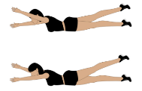  Swimmers | 3 sets
 | 30 sec.
 | Wt.
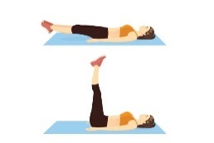  Leg  Raises | 3 sets
 | 20 reps
 | Wt.
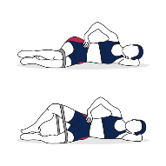  Clams | 3 sets
 | 15 reps
 | Wt.
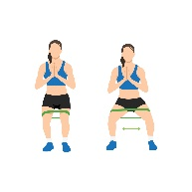  Crab  Walk | 3 sets
 | 15 reps
 | Wt.
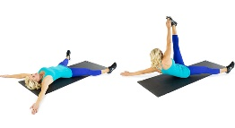  Starfish  Crunch | 3 sets
 | 20 reps
 | Wt.
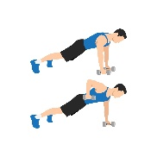  Plank  Row | 3 sets
 | 15 reps
 | Wt.

As you surface from the “Trident Triumph Circuit”, relish the strength, agility, and aquatic inspiration that define this workout. Channel the spirit of Aquaman and emerge from each exercise as a triumphant ruler of your fitness domain. Conquer the waves, both in the gym and in life, with the power of Atlantis behind every move.

Name When Completed:

