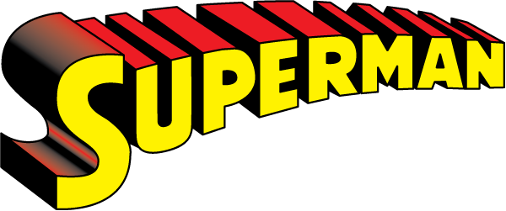

Welcome to "The Man of Steel Challenge," designed to push your limits and unleash the strength of Superman within you! Just like the Man of Steel, this routine focuses on building incredible strength, endurance, and agility. Whether you're saving the world or just looking to elevate your fitness, this workout is your secret weapon.

1. Super Strength Push-Ups- Diamond Push-Ups: 3 sets of 12 reps
- Focus on upper body strength, mimicking the force of Superman's powerful arms.

2. Heat Vision Holds - Wall Sit: 3 sets of 45 seconds
- Build lower body endurance, as if harnessing the energy for Superman's heat vision.

3. Bulletproof Burpees - Burpees: 3 sets of 10 reps
- Enhance agility and explosiveness, readying yourself to dodge any obstacle.

4. Caped Crusader Step ups - Weighted Step Ups: 3 sets of 10 each leg
- Rapid leg movement to boost cardiovascular endurance, echoing Superman's quick reflexes.

5. Heroic Hyperextensions - Supermans: 3 sets of 15 reps
- Strengthen the lower back, crucial for Superman's flight and posture.

6. Skyward Shoulder Press - Overhead Press: 3 sets of 10 reps
- Enhance shoulder and arm strength for those high-flying heroics.
Exercises: | Sets  Reps  Wt. | M | T | W | T | F | S | S
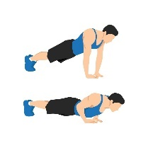  Diamond  Pushups | 3 sets
 | 12 reps
 | Wt.
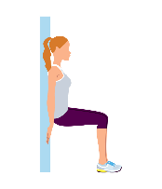  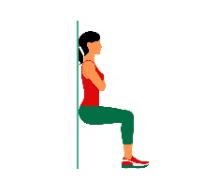  Wall Sit | 3 sets
 | 45 sec.
 | Wt.
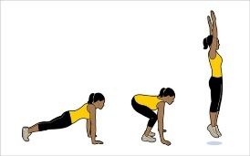  Burpees | 3 sets
 | 10 reps
 | Wt.
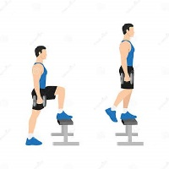  Weighted  Step Ups | 3 sets
 | 10 reps
 | Wt.
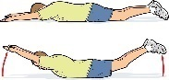  Supermans | 3 sets
 | 15 reps
 | Wt.
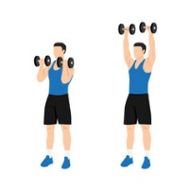  Overhead  Press | 3 sets
 | 10 reps
 | Wt.

You've just completed "The Man of Steel Challenge," and are one step closer to achieving your superhero potential! Like Superman, you possess unique strengths and abilities that this workout helps you discover and develop. Keep challenging yourself, and remember, your true power lies in your dedication, resilience, and the courage to push beyond your limits.

Name When Completed:

