Embrace the power of Thanos with the Titan Strength Workout. This intense routine is designed to make you feel as unstoppable as the Mad Titan himself. Get ready to conquer the universe with brute strength and endurance.

1. Infinity Gauntlet Deadlifts: 3 sets of 10 reps
- Load up a barbell with challenging weight.

2. Power Stone Pull-Ups: 3 sets of 10 reps
- Use a pull-up bar, resistance bands, or assisted pull up machine.

3. Meteor Strike Slam Balls: 3 sets of 15 slams
- Hold a medicine ball overhead. Slam it into the ground with full force.

4. Reality Stone Wood Chops: 3 sets of 10 reps each side
-Hold MB low and swing across body to other side high.

5. Mind Stone Plank: 3 sets of 20 taps (10 on each shoulder)
- Get into a plank position with forearms on the mat. Alternate tapping each shoulder with your hand.

6. Space Stone Sprints:
- Find an open space or treadmill. Walk for 30 sec. then Sprint for 30sec.
- Repeat for a total of 8 sprints.

Exercises: | Sets  Reps  Wt. | M | T | W | T | F | S | S
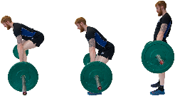  Deadlifts | 3 sets
 | 10 reps
 | Wt.
Pull-ups | 3 sets
 | 10 reps
 | Wt.
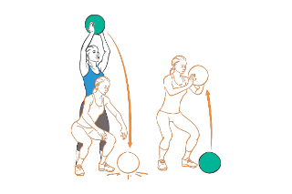  MB Slam  Balls | 3 sets
 | 15 reps
 | Wt.
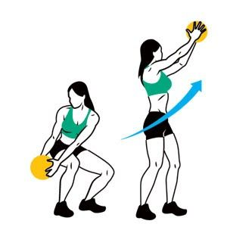  MB Wood  Chops | 3 sets
 | 10 reps
 | Wt.
Plank  Shoulder  Taps | 3 sets
 | 20 reps
 | Wt.
Sprint  Intervals | 3 sets
 | 30/30 sec.

You've conquered the universe with the Titan Strength Workout! Channel your inner Thanos and let the power flow through you.

Name When Completed:

