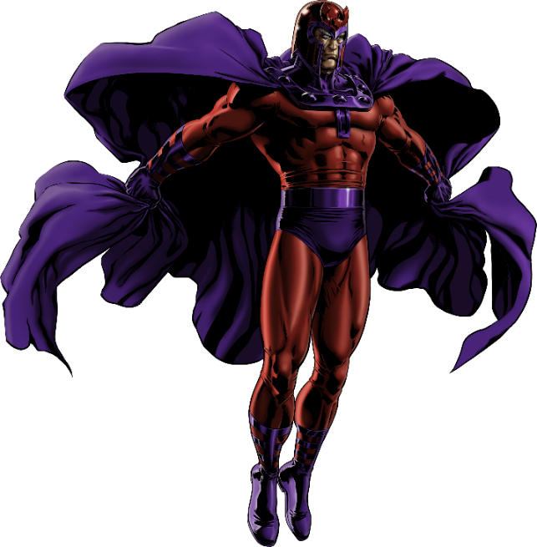

Embrace the dark intensity of Magneto with the Dominance of Doom workout. This program is inspired by the magnetic mastermind's strength, control, and determination. Prepare to push yourself to the edge, testing the limits of your physical and mental endurance. Every exercise is a step closer to embodying the formidable power of Magneto, challenging you to rise above mere mortal capabilities.

1. Magnetic Lifts (Deadlifts) - 3 sets of 8 reps
- Channel Magneto's power to lift metal as you execute each deadlift with precision and control.

2. Core of Steel (Russian Twists with Weight Plate) - 3 sets of 15 reps each side
- Strengthen your core, imagining the weight plate as a piece of metal controlled by your magnetic force.

3. Iron Clad Push-Ups (Weighted Push-ups) - 3 sets of 10 reps
- Feel the weight on your back as if it's being pulled by Magneto’s magnetic fields, enhancing your upper body strength.

4. Telekinetic Squats (Barbell Squats) - 3 sets of 8 reps
- Focus on the squat, envisioning yourself manipulating heavy objects with your mind and body.

5. Magnetic Grip Hangs (Dead Hangs) - 3 sets of 30 seconds
- Imagine suspending yourself in the air using magnetic force, gripping the bar tightly.

6. Force Field Planks (Plank Hold) - 3 sets of 1 minute
- Maintain a strong plank, visualizing an unbreakable magnetic force field around you.

Exercises: | Sets  Reps  Wt. | M | T | W | T | F | S | S
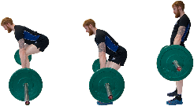  Deadlifts | 3 sets
 | 8 reps
 | Wt.
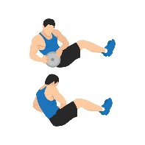  Russian  Twists | 3 sets
 | 15 reps
 | Wt.
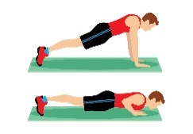  Pushups | 3 sets
 | 10 reps
 | Wt.
Barbell  Squats | 3 sets
 | 8 reps
 | Wt.
Dead Hangs | 3 sets
 | 30 sec.
 | Wt.
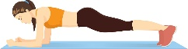  Plank | 3 sets
 | 1 min.
 | Wt.

Well done on conquering the "Dominance of Doom" workout! Like Magneto, you've demonstrated immense power and control, challenging your physical limits and emerging stronger. This workout is a testament to your willpower and determination. Stay strong and keep channeling your inner Magneto!

Name When Completed:

