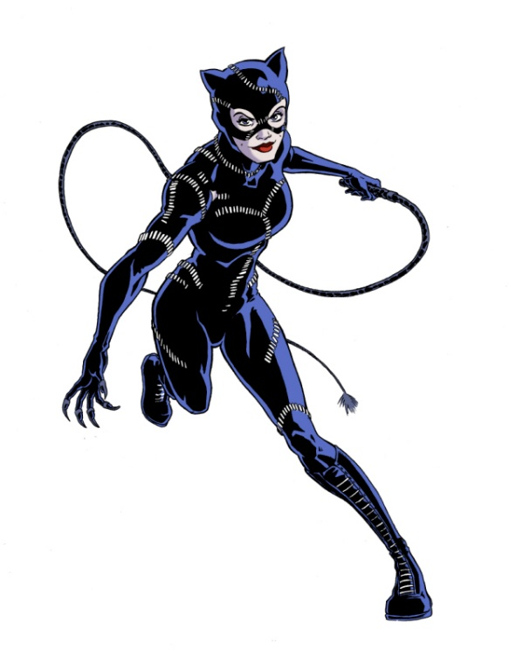

Welcome to Catwoman's Clawed Conquest! Prepare to embrace your inner villainess and sculpt a physique as sleek and deadly as Gotham's infamous feline prowler. You'll unleash your agility, strength, and stealth to dominate the urban jungle.

1. Cat Burglar Crawl: 3 sets of 10 Forward/10 Backward Bear Crawls (20 Total reps)
-Channel your inner cat burglar as you crawl stealthily forward and backward on all fours.

2. Claw Slash Step Up w/Knee Drive: 3 sets of 15 reps each side
-Stand tall and step up on bench with a powerful knee drive and arms forward as if swiping with claws.

3. Stealthy Overhead Tricep Extension: 3 sets of 10 reps
-Hold the weight in both hands, lift it overhead, extending your arms fully.

4. Pouncing 180° Jump Squats: 3 sets of 10 jumps
-Start in a squat position, then explode upward turning 180 degrees, facing the other direction.

5. Catnip Crunches: 3 sets of 25 reps
-Lie on your back, then lift your shoulders off the ground as you crunch upward reaching for an imaginary piece of catnip.

6. Feline Flexibility (Cat-Cow Stretch): 3 sets of 5 rounds
- Inhale into cow position (arched spine, belly button low) and exhale into cat position (rounded spine, belly button high).

Exercises: | Sets  Reps  Wt. | M | T | W | T | F | S | S
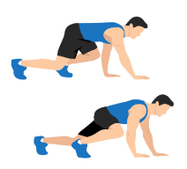  Bear  Crawls | 3 sets
 | 20 reps
 | Wt.
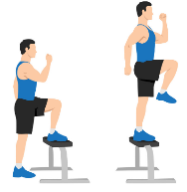  Step Up  w/Knee  Drive | 3 sets
 | 15 reps
 | Wt.
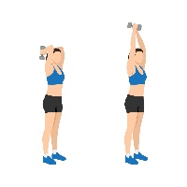  Overhead  Tricep  Extension | 3 sets
 | 10 reps
 | Wt.
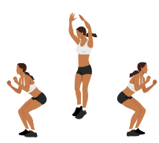  180°  Jump  Squats | 3 sets
 | 10 reps
 | Wt.
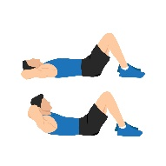  Crunches | 3 sets
 | 25 reps
 | Wt.
Cat-Cow  Stretch | 3 sets
 | 5 rounds
 | Wt.

Congratulations, fierce feline! You've conquered Catwoman's Clawed Conquest, embodying the strength, agility, and allure of Gotham's most notorious anti-heroine. Keep honing your skills and may your prowling prowess continue to inspire fear and admiration in equal measure. Until next time, stay sleek and deadly!

Name When Completed:

