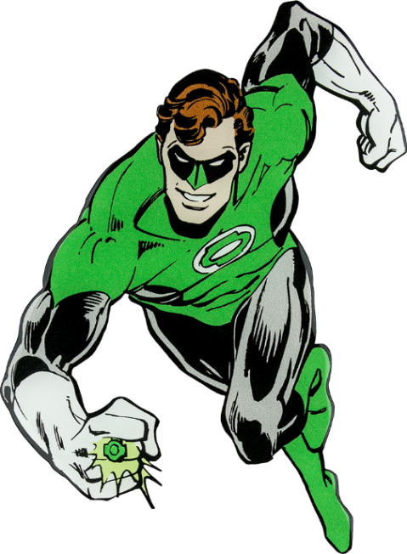

Welcome, fearless recruits, to the Power Ring Workout, designed to sculpt your physique into that of a true Green Lantern! With unwavering willpower and determination, you'll harness the strength and agility needed to protect the universe. Let's embark on this heroic journey together and ignite the power within!

1. Ring Charge Planks: 3 sets of 30 sec.
-Assume a plank position, channeling the energy of your power ring to maintain a strong and steady core.

2. Willpower Skull Crushers: 3 sets of 10 reps
-Lay on a bench or floor. Flex your elbows and lower yourself with control to skull, then push back up explosively, embodying the resilience of a Green Lantern.

3. Oath Reverse Lunges w/Shoulder Press: 3 sets of 20 reps
-Recite the Green Lantern oath as you perform alternating reverse lunges while lifting weights and knee up.

4. Construct Decline Sit-ups: 3 sets of 10 reps
- Lie on your back on decline bench and visualize constructing a green energy shield around your core.

5. Power Ring Single Leg Deadlifts: 3 sets of 10 reps each side
- Stand with your feet shoulder-width apart, dumbbells in hand, ready to leap into action. Bend down towards toes, lifting other leg behind you getting ready to fly.

6. Flight Speed Skaters: 3 sets of 20 reps
-Visualize yourself soaring through space as you jump side to side, arms pumping with the intensity of a Green Lantern in pursuit of justice.
Exercises: | Sets  Reps  Wt. | M | T | W | T | F | S | S
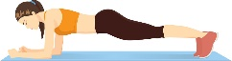  Plank | 3 sets
 | 30 sec.
 | Wt.
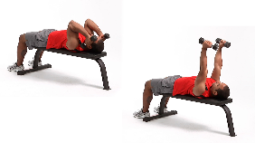  Skull  Crushers | 3 sets
 | 10 reps
 | Wt.
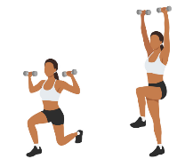  Reverse  Lunge w/  Shoulder Press | 3 sets
 | 20 reps
 | Wt.
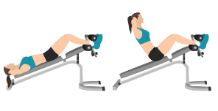  Decline  Sit-ups | 3 sets
 | 10 reps
 | Wt.
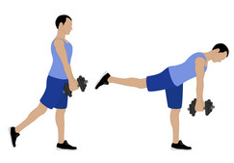  Single Leg  Deadlift | 3 sets
 | 10 reps
 | Wt.
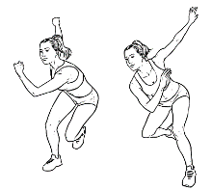  Speed  Skaters | 3 sets
 | 20 reps
 | Wt.

Congratulations, brave recruits, for completing the Power Ring Workout! By embracing the spirit of the Green Lantern, you've tapped into your inner strength and unlocked your true potential. Now, go forth with confidence, knowing that you possess the power to overcome any challenge that comes your way. In brightest day, in blackest night, let your fitness journey shine with the light!

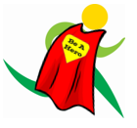
Name When Completed:

